8.71: a) Take the original direction of the bullet’s motion to be the x-direction,
and the direction of recoil to be the y-direction. The components of the stone’s velocity
after impact are then

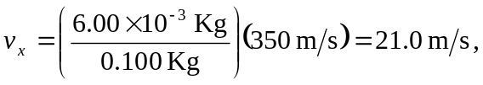

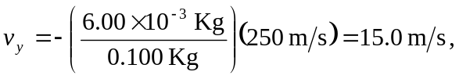

and the stone’s speed is 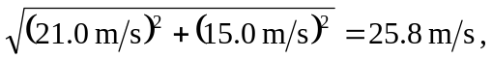 at an angle of arctan 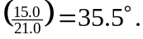 b)
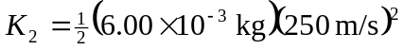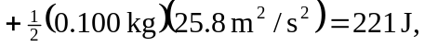so the collision is not perfectly elastic.

